Purpose
CUSTOMER requested an assessment of the fundraising potential for the CU School of Underwater Basket Weaving. They are benchmarking this school with peers as part of their strategic planning process. One of the focus areas for the strategic plan (draft version) is diversifying financial resources.
Recommendation
The CU School of Underwater Basket Weaving (SUBW) has a healthy prospect pool of alumni, donors, and organizations. Many donors to SUBW also give elsewhere at CU.
When reviewing the SUBW pool, it is clear it is appropriately managed. Those with high capacity, high affinity, and a history of giving to CU are managed primarily by staff supporting that school.
27% of recent (past 5 years) donors to the SUBW are alumni of the SUBW, though only one alum is giving at a major gift level. Increasing engagement with individual donors could increase giving, especially giving by SUBW alumni in particular and also alumni of other programs who have previously given to the SUBW. Focusing on individual donors whose giving falls in the $1,000-$9,999 band could also lead to increased major gift activity.
Analysis
Overall SUBW Pool
The pool analyzed includes all SUBW alumni, including those who are not donors, and all donors to SUBW who have made a gift in the past 5 years (since July 1, 2015, to capture 5 full fiscal years). INSERT ADDITIONAL POOL CRITERIA HERE
The pool contains 3,447 entities who would be considered prospects for the SUBW. 3,346 of these entities are individuals, while 101 are organizations. 869 are donors, including 237 donors who are also alumni of the SUBW. 27% of donors to the SUBW are also alumni of the SUBW. Organization donors make up 3% of the prospect pool (which also includes alumni) and 12% of the donor pool. The remainder of the donor pool is composed primarily of alumni to other programs at CU (39% of overall SUBW donor pool) and friends (13%).
Giving Trends of the Prospect Pool
Based on our pool, the giving analysis below focuses on donors who have made a gift to SUBW in the past 5 years (since July 1, 2015). Only one SUBW alum is giving at a major gift level. Although the pool has a very low number of organization donors, they make up 71% of the donors who have made a gift of $10,000 or more to SUBW. There is a pool of 77 individual donors and 25 organization donors with lifetime giving in the $1,000-$9,999 band who could be good prospects to review to convert to major gift donors. Of those 77 individuals, 7 have capacity ratings of $250,000-$999,999, 22 have capacities of $100,000-$249,999, and 12 have capacity ratings of $25,000-$99,999, totaling 41 individuals with major gift capacity. 31 of those 77 individuals, plus 3 organizations, are currently managed prospects.
SUBW Lifetime Giving Total | People / Individual Donors |  | Organizations | Total
 | SUBW Alumni | Non-SUBW Alumni
$1,000,000+ | 0 | 2 | 6 | 8
$100,000-$999,999 | 1 | 8 | 24 | 33
$10,000-$99,999 | 0 | 14 | 30 | 44
$1,000-$9,999 | 10 | 67 | 25 | 102
Less than $1,000 | 226 | 440 | 16 | 682
Total | 237 | 531 | 101 | 869

There are 2,815 SUBW alumni in this pool, 2,578 of whom have never made a gift to the SUBW (91%). Acquisition efforts around this alumni pool could help build the donor base. Of the alumni who are not also donors to SUBW, 234 have giving to CU, 1 in the lifetime $100,000-$999,999 band and 4 in the $10,000-$99,999 band. 112 non-SUBW donor alumni have giving elsewhere at CU.
Lifetime Giving Range | Giving to CU |  | Giving to Basket Weaving
 | # of Prospects | % of Pool | # of Prospects | % of Pool
$1,000,000+ | 33 | 0.96% | 8 | 0.23%
$100,000-$999,999 | 42 | 1.22% | 33 | 0.96%
$10,000-$99,999 | 51 | 1.48% | 44 | 1.28%
$1,000-$9,999 | 134 | 3.89% | 102 | 2.96%
Less than $1,000 | 843 | 24.45% | 682 | 19.78%
Never given | 2,344 | 68.00% | 2578 | 74.79%
Total Overall | 3,447 |  | 3,447

The chart above shows a lack of giving to SUBW within its donor and alumni prospect pool. Of the 33 donors to CU in this pool with giving of $1 million or more, 11 percent on average of these prospect’s lifetime giving to CU is going to SUBW, with only one donor (SPECIFIC DONOR INFO) contributing 100% of their CU giving to the SUBW, only one more giving over half (SPECIFIC DONOR INFO), and 27 of the 33 donors giving less than 10% of their CU giving to SUBW.
Organizations make up a substantial part of the group of donors to SUBW who have given $10,000 or more lifetime to SUBW (71% of donors are organizations). They are however most likely to have a low percentage of their CU giving allocated for the SUBW. For individuals and organizations who have given more than $10,000 lifetime to SUBW, the average percentage of their CU giving that went to the SUBW is 38% for organizations and 71% for individuals.
Overall Giving Trends
The following chart tracks all donors who have made a single gift of $10,000 or more to the SUBW, by last gift date to the SUBW, broken down by organizations and individuals. Most of the individual donors who have given $10,000 or more are still donors or are recent donors, which is very good engagement with this group. Organizations are more likely to have lapsed. The individuals who have lapsed 3 or more years ago are largely still alive; per our database only 9 of the 57 individual donors who have made a gift of $10,000 or more to the SUBW and are lapsed are deceased. This lapsed pool, while small, could be worth reviewing to determine if any of them could be re-engaged. The same could easily apply to organization prospects, especially those who lapsed within the last 2-5 years (25 organizations lapsed in FY2019-2016).
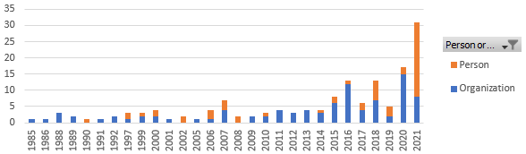
The fundraising chart below begins in 2007, the first year that giving totaled above $350,000. Average fundraising from 1984-2006 was $120,507/year, primary driven by gifts under $25,000. Notable gifts from 1984-2006 above $25,000 include:
- $######## in year from SPECIFIC DONOR INFO, description of gift (named a scholarship, created an endowment, in honor of someone, etc.)
- $######## in year from SPECIFIC DONOR INFO, description of gift
- $######## in year from SPECIFIC DONOR INFO, description of gift
- $######## in year from SPECIFIC DONOR INFO, description of gift
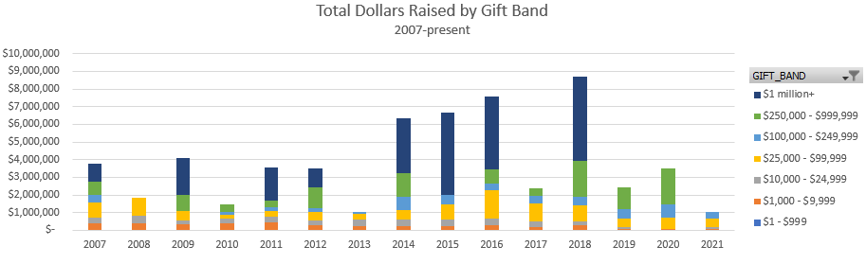
The chart above looks at total dollars raised by gift band starting in 2007, when the SUBW began to more successfully raise gifts of above $25,000. Of the $1 million gifts made beginning in 2007, all but one of them were from SPECIFIC DONOR INFORMATION, which has contributed a total of $##,###,### cumulatively to the SUBW. This is largely responsible for the increase in donations in 2014-2016 and 2018, though strong giving in the bands from $10,000 and up also helped with the pipeline. Per the chart below, starting in 2017 overall donor counts have generally been decreasing, though so far 2021 has been a strong year for donor counts.
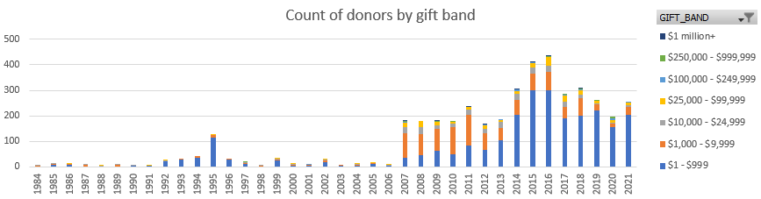
^{2 (see footnotes)}
The increase in donations and donors in 2007 is driven by giving to the School of Underwater Basket Weaving Fund, a direct to university gift fund. Other top allocations supported by gift count in the SUBW since 2007 include the Fund A, Fund B, and Fund C. Based on giving totals since 2007, top allocations are the:
- Fund Name (Accounting #, brief description) - $#,###,### total
- Various funds associated with SPECIFIC DONOR INFO
- Fund Name (Accounting #, brief description) - $#,###,### total
  - Information about the formation or history of this fund that was interesting
- Fund Name (Accounting #, brief description) - $#,###,### total
  - This fund has primarily been supported by SPECIFIC DONOR INFO though many friends and family have also given smaller gifts
- Fund Name (Accounting #, brief description) - $#,###,### total
- Fund Name (Accounting #, brief description) - $#,###,### total
  - Information about the formation or history of this fund that was interesting

SUBW DonorCentrics Donor Retention Dashboard – By Donor Type
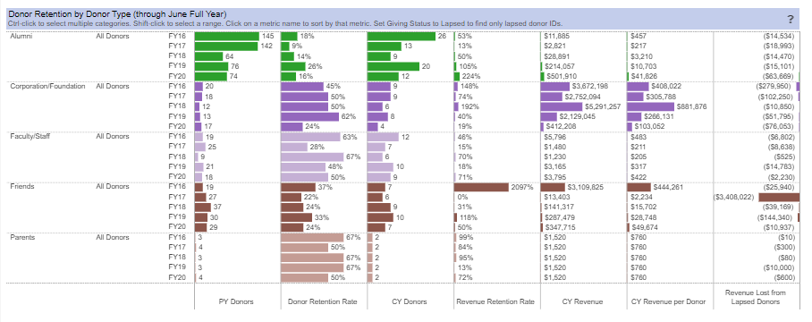Among individuals (alumni and friends especially) revenue per donor has been increasing over time, aside from a decrease in friends revenue between FY16-17, likely driven by strong prior giving to the SPECIFIC FUND INFO in FY15 and FY16. Alumni retention could be improved, which might help stabilize revenue. This data further proves that with corporation and foundation donors, the actions of a small number of organizations is having a big impact.
SUBW DonorCentrics Donor Retention Dashboard – Overall²
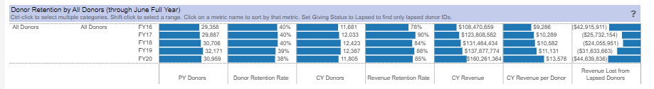Looking at retention for the pool overall, not broken down by donor type, shows more consistent donor retention. Revenue lost from lapsed donors is concerning, though as stated above, likely the actions of a few donors are having a disproportionate impact on this overall statistic. Annual giving is not currently concerned about the attrition of number of donors. They’ve seen with other units that donors who paused their giving in 2020 are already returning in 2021. Annual Giving Network is also showing trends in that direction. Potentially gift officer outreach to those who lapsed in 2020 could produce good results.

SUBW DonorCentrics Revenue Gains and Losses Dashboard
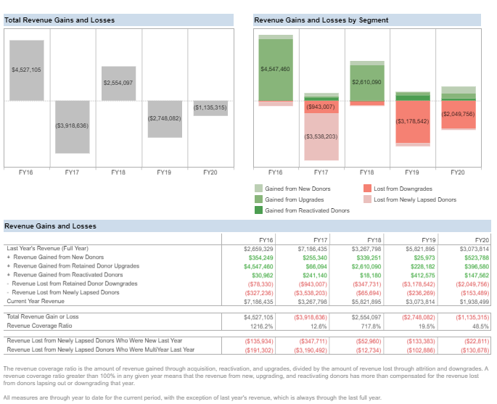
Continuing donors, both those who upgrade and those who downgrade, have the biggest impact on revenue gains and losses. In FY20, new donors helped with gains and downgrades decreased, which is a promising trend that will hopefully continue once FY21 is wrapped up.

AMC SUBW DonorCentrics Donor Gains and Losses Dashboard
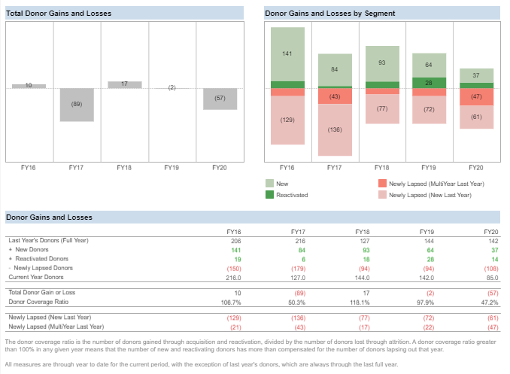
Recent losses in lapsed donors are not being made up for with gains in new and reactivated donors. However, given the size of the SUBW donor pool overall, targeted outreach could help improve retention. Overall, with such a small pool, targeted outreach to retain existing donors and make gains with new donors could have a big impact. Crowdfunding could be particularly important here for retaining donors who may not feel compelled, long-term, by scholarship or general fund messaging.

Major Gift Prospect Pool
Managed Prospects
There are 182 prospects in this pool that are currently managed (5% of pool). Of those, 158 are managed by SUBW fundraisers (87%). 62 of those prospects have a major gift capacity of $100,000+ (34%) while 100 have a gift capacity of $25,000+ (55%). Note: 42 prospects are organizations with no gift capacity listed.
Unmanaged Prospects
The unmanaged prospect pool includes 3,265 entities. This includes 3,206 individuals and 59 organizations.
When reviewing individuals with a gift capacity of $25,000+, the potential prospect pool includes 896 individuals. Within this group, 749 also have a high affinity to the SUBW. 54 of these prospects have previously been managed. However, only 259 prospects in this pool have made a gift to CU (35%). That leaves 490 prospects that have never made a gift to CU (65%), despite their high capacity and affinity.
When narrowing down the pool to prospects with a high gift capacity of $100,000+ and a high SUBW affinity score, this brings us to 201 prospects. Of those, 90 have made a gift to CU (45%). This leaves 111 that have never given to CU (55%). Only 21 (10%) of these major gift prospects have been previously managed. Assuming those 21 prospects have been disqualified, this leaves a major gift prospect pool of 180. Of this group of 180, 154 have had at least one contact report entered (note: this may include student callers).
Of the unmanaged organizations (59), 34 have a lifetime giving of $10K+ to CU and 23 have a lifetime giving of $10K+ to the School of Underwater Basket Weaving.
Overall Pool Contact
In the pool as a whole (including both managed and unmanaged prospects), 64% (2,215 entities) have had at least one contact report (this includes student callers). In addition, 8% of the total pool (292 entities) have had at least one significant contact.
Significant contact includes: personal visit, group setting visit, video conference, and phone call-spoke to donor.
Gift Capacity
Capacity | Number of prospects
$10,000,000+ | 1
$1,000,000-$10,000,000 | 6
$250,000-$999,999 | 53
$100,000-$249,999 | 248
$25,000-$99,999 | 688
$10,000-$24,999 | 183
$2,500-$9,999 | 502
Less than $2,500 | 32
Unable to rate | 1,130
Blank/Orgs | 604
Total overall | 3,447

Footnotes can be helpful for specific donor info that may be distracting as part of the general text ² The increase in gift count in 1995 was largely driven by gifts to the INSERT FUND INFORMATION HERE (most likely a memorial fund, 115 of the 197 gifts that year), along with gifts to the FUND INFORMATION (38 of the 197 gifts).
Source: DonorCentrics, data also discussed with Annual Giving team for conclusions
Source: DonorCentrics, data also discussed with Annual Giving team for conclusions
Source: DonorCentrics, data also discussed with Annual Giving team for conclusions

